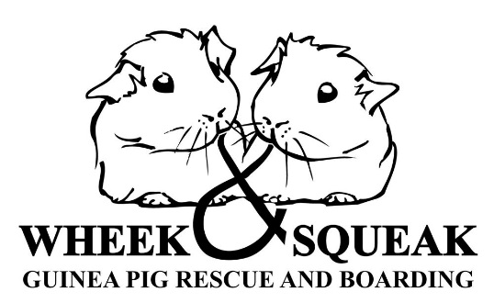

**OUR REHOMING POLICIES**

Guinea pigs need to be looked after correctly to make sure they are kept healthy and happy. We therefore believe in the Five Freedoms to make sure they have the best possible life they could have.

*The****Five Freedoms****outline five aspects of*[*animal welfare*](https://en.wikipedia.org/wiki/Animal_welfare)*under human control. They were developed in response to a 1965*[*UK Government*](https://en.wikipedia.org/wiki/Government_of_the_United_Kingdom)*report on livestock husbandry, and were formalised in 1979 press statement by the*[*UK Farm Animal Welfare Council*](https://en.wikipedia.org/wiki/Farm_Animal_Welfare_Committee#Farm_Animal_Welfare_Council)*. The Five Freedoms have been adopted by professional groups including*[*veterinarians*](https://en.wikipedia.org/wiki/Veterinarians)*, and organisations including the*[*World Organisation for Animal Health*](https://en.wikipedia.org/wiki/World_Organisation_for_Animal_Health)*, the*[*Royal Society for the Prevention of Cruelty to Animals*](https://en.wikipedia.org/wiki/Royal_Society_for_the_Prevention_of_Cruelty_to_Animals)*, and the*[*American Society for the Prevention of Cruelty to Animals*](https://en.wikipedia.org/wiki/American_Society_for_the_Prevention_of_Cruelty_to_Animals).

Therefore, our rehoming policies are as listed below:

Guinea pigs need space to express normal behaviour. The minimum hutch/cage size should be 4ft x 2ft for 2 guinea pigs, 5ft x 2ft for 3 guinea pigs and 6ft x 2ft for 4 guinea pigs, the larger the better. The hutch should be on one level (**we do not approve of steep ramps**) with a separate secure wooden run to be used on suitable warm, dry days. When a hutch is outside it should be at least 12 inches off the ground. Hutch huggers, our views of hutch huggers are they are fine when just covering the hutch but when the front is brought down and zipped there is not enough air circulating and therefore becomes damp and can cause health issues.

We prefer that guinea pigs live indoors. There is a lot more interaction with them and they are kept out of our cold damp weather. Guinea pigs can live outside during our summer but we recommend they are kept indoors from, probably October through to April or May.

They should be given the correct diet hay, fresh vegetables and dried guinea pig food with fresh water every day.

The hutch should be kept clean on suitable bedding that is healthy for them. We do not recommend shavings. Our favourite is Megazorb but we are happy to recommend other beddings.

Guinea pigs will probably from time to time need a vet. This can be expensive and run into many hundreds of pounds. Please think long and hard whether you can afford this.

After adopting guinea pigs from us we do ask that if at any time you cannot keep them that they are returned to The Wheek & Squeak Guinea Pig Rescue. If you adopt from us we are here as support for the whole lifetime of the guinea pigs.

We also ask that they are not used for breeding.

The majority of guinea pigs in our rescue had been bought as a child’s pet. As childrens interest in anything is very sporadic we do not home guinea pigs where they are bought solely for children.